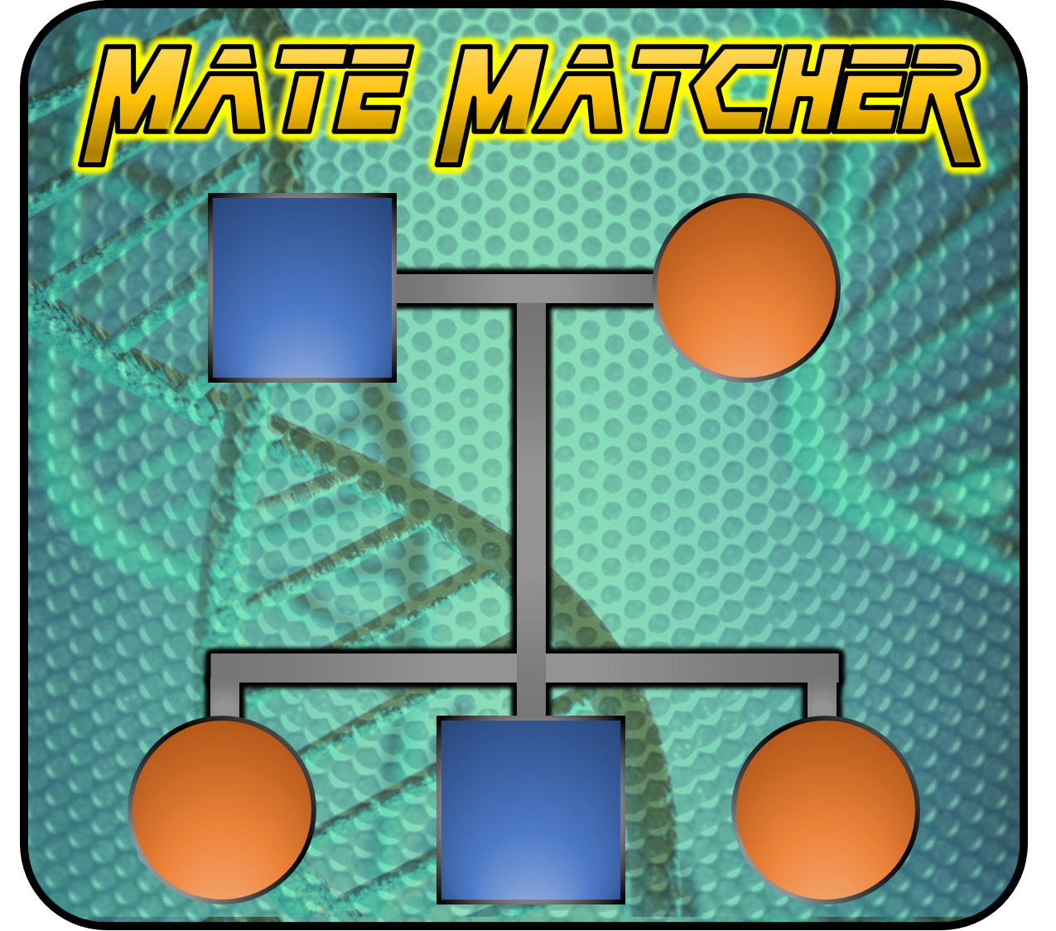

**Mate Matcher**

**Mating Optimization Software**

**User Guide**

**Version 1.01 May 4th, 2020**

Jason A. Coombs

University of Massachusetts, Amherst

Keith H. Nislow

U.S. Forest Service

**Table of Contents**

Introduction

Installation

Start-up

Main Form Part I

Database Specifications

Warning Flag Settings

Mating Design

Relatedness Metric

Individual Input Form

Updating Individual Information

Creating Mating Pairs

Main Form Part II

Re-optimization

Appending Mated Pairs

Recording of Non-optimized Pairs

**Introduction**

Mate Matcher is a software program used for real-time pairing of mating individuals through optimization of all possible pairings for minimization of genetic relatedness.

**Installation**

To install Mate Matcher save the executable, MSCOMM32.OCX, and MSVBVM60.DLL files all to the same folder. In some instances, the OCX and DLL files may need to be added to the computer’s registry. The following links provide instructions to do so: [MSCOMM32.OCX](https://github.com/davidanger/MSCOMM32) and [MSVBVM60.DLL](https://support.microsoft.com/en-us/help/180071/file-msvbvm50-exe-installs-visual-basic-5-0-run-time-files).

For both installs, admin rights will be needed.

For the MSCOMM32.OCX install:

* Download all files in the github repository by clicking on the green ‘Code’ button and then clicking ‘Download ZIP’.
* Unzip the downloaded file.
* Move the MSCOMM32.OCX file to the C:\Windows\SysWOW64 folder.
* Open the command prompt as an administrator. NOTE: May need to go to the C:\Windows\System32 folder and right-click on the cmd.exe file and select ‘Run as administrator’.
* At the command prompt, enter ‘cd C:\WindowsSysWOW64’ to change to that directory.
* At the prompt, run the following commands:
  + regsvr32 /u C:\WINDOWS\SysWOW64\MSCOMM32.OCX
  + regsvr32 /i C:\WINDOWS\SysWOW64\MSCOMM32.OCX
  + regsvr32 C:\WINDOWS\SysWOW64\MSCOMM32.OCX
* Open Registry Editor as an administrator. NOTE: May need to go to the C:\Windows folder and right-click on the regedit.exe file and select ‘Run as administrator’.
* In Registry Editor, click ‘File’ on the top menu, then click ‘Import’ and open the ‘Regedit_MSCOMM32.reg’ file found in the unzipped folder from the initial step.

For the MSVBVM60.DLL, simply double click on the downloaded VB6.0-KB290887-X86.exe file to run the install.

**Start-up**

On start-up, Mate Matcher will preload all of the possible mating combinations in order to increase performance during real-time mating optimization. This process takes approximately 30 seconds to complete, and a progress bar on the splash page will inform you of the status.

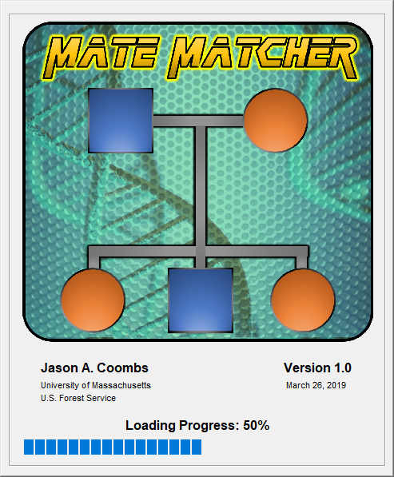

**Main Form Part I**

Upon completion of the mating combination loadings, the main form will open. Hovering the cursor over an item will usually show descriptive text about that item. If this is the first time that Mate Matcher has been used, you will be prompted to specify database settings.

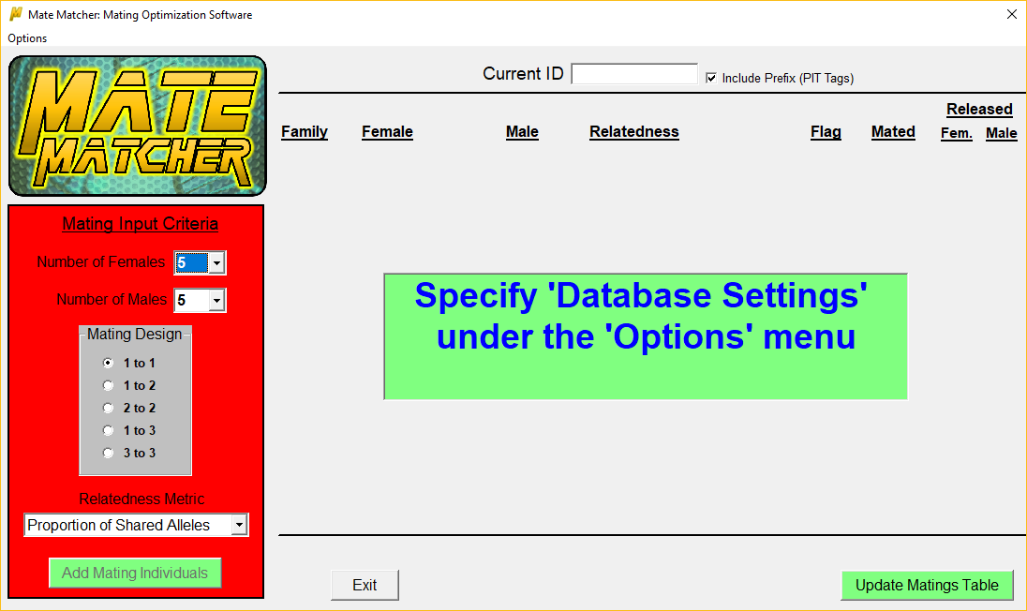

On subsequent opening of Mate Matcher, attempts will be made to connect to the previously used database.

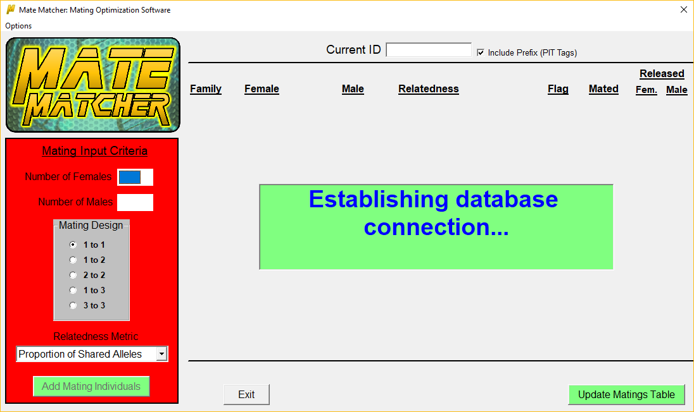

**Database Specifications**

Open the database specifications window by clicking ‘Options’ on the top menu of the main form and selecting ‘Database Settings’. On your initial usage of Mate Matcher, you will be required to do the following:

1. Select a mating database
   1. Must be a Microsoft Access database (either .mdb or .accdb extensions will work)
2. Select the table in the database that contains genotypes of individuals to be used for mating (genetics table)
3. Map columns in the genetics table to their associated field
   1. Unique Identifier, Sex, Number of Loci, First Locus, and Comments are required
      1. There must be two fields for each locus (diploid, 2 alleles)
      2. All allelic fields must be contiguous in the table (2 x number of loci)
   2. Population, Cohort, and Flag are optional and will only be used when checked
      1. Cohort must be a field with numeric data type
4. Select the table in the database where the mating pairs will be recorded
   1. The user can either select an existing table or create a new table
      1. An existing table requires the mapping of all fields to columns in the table
         1. If a field does not currently exist in the table it will need to be added
         2. See the below table for required data types of each field
      2. A new table requires the user to enter in a table name
         1. All fields are auto populated with column headings
5. Click ‘Save’ button to store the database settings

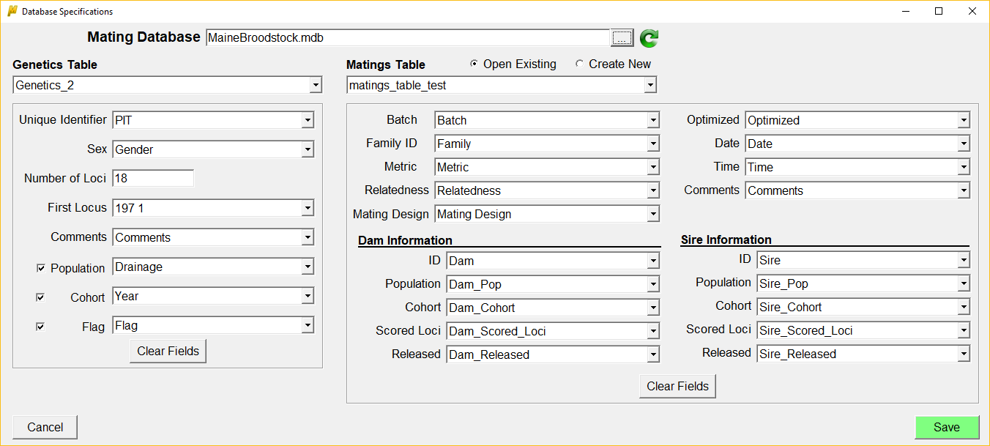

|  |  |
| --- | --- |
| **Genetics Table** | |
| **Field** | **Description** |
| Unique Identifier | The unique identifier of the individual |
| Sex | The gender of the individual (e.g. M, F, U) |
| Number of Loci | The number of loci comprising the genotypes of all individuals |
| First Locus | The column corresponding to the first locus reading from left to right in the table |
| Comments | Any comments about the individual, included when adding new individuals to the table |
| Population | The population of the individual |
| Cohort | The cohort of the individual, **NOTE: Must be a numeric field** |
| Flag | Warning flags about the individual that will be displayed if used for mating |

|  |  |  |
| --- | --- | --- |
| **Matings Table** | | |
| **Field** | **Allowed Data Type** | **Description** |
| Batch | Long, Single, Double, Decimal | Auto assigned unique identifier of mating pairs matched under the same optimization |
| Family ID | Text | User supplied identifier of the mating pair |
| Metric | Text | The relatedness metric used for optimization |
| Relatedness | Single, Double, Decimal | The relatedness value of the mating pair |
| Mating Design | Text | The mating design used when optimizing mating pairs |
| Optimized | Text | Whether the mating pairs were matched using relatedness optimization; can be yes, no, or reoptimized |
| Date | Date/Time | The date the mating pair reproduced |
| Time | Date/Time | The time the mating pair reproduced |
| Comments | Text | Notes regarding the mating pair, specifically any mating flags violated |
| ID | Text | The identifier of the dam/sire |
| Population | Text | The population of the dam/sire |
| Cohort | Long, Single, Double, Decimal | The cohort of the dam/sire |
| Scored Loci | Long, Single, Double, Decimal | The number of loci scored for the dam/sire genotype |
| Released | Yes/No | Whether the dam/sire was released into the wild after mating |

**Warning Flag Settings**

Open the warning flag settings window by clicking ‘Options’ on the top menu of the main form and selecting ‘Warning Flag Settings’. These settings provide options for raising warning flags if mating pairs meet flag specifications. Any raised flags will appear on the main form after mating pairs have been assigned.

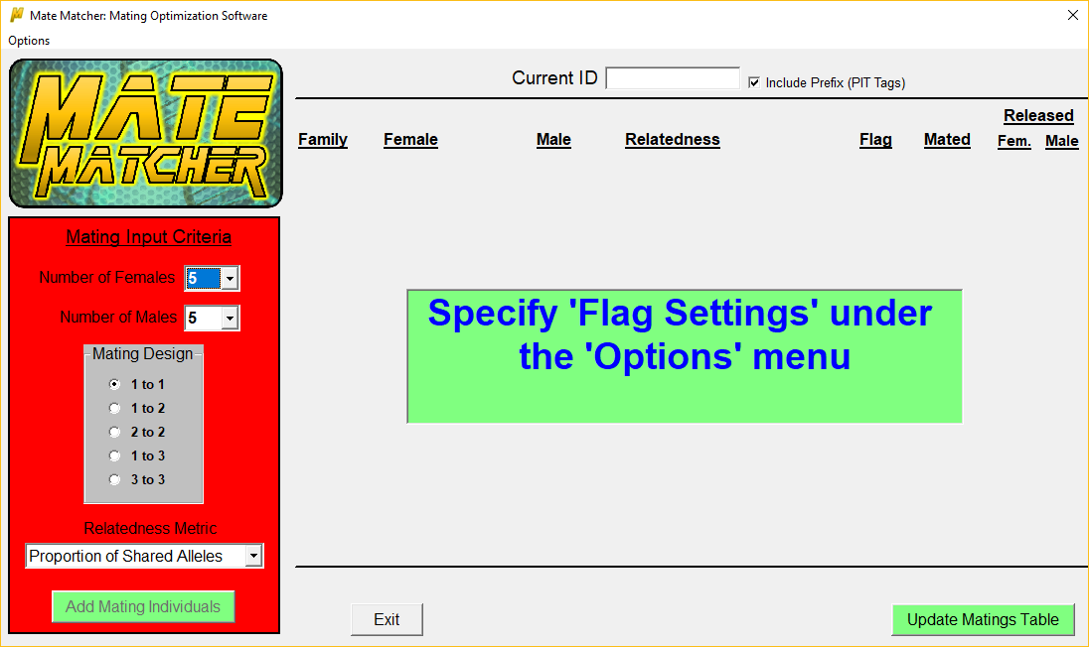

Available flags include:

* A mating pair has a genetic relatedness value greater than the specified maximum
  + To use this flag pairwise relatedness values must be calculated first
    - Calculations are performed separately for each population (if population is specified)
    - Only individuals present in the specified ‘Cohorts to go Back’ are included
      * **NOTE**:
        + Depending on the number of individuals the time to calculate these values can reach upward of an hour
        + A large number of individuals (~10,000-15,000) may result in a memory shortage error

In these instances, you may need to limit the number of cohorts to go back

* + - Once calculations have been completed, the pairwise relatedness value corresponding to the specified maximum percentile can be viewed by clicking on the ‘View Values’ button
* One or both mating individuals has allelic information present at less than the specified minimum number of loci
  + Unscored alleles should be represented by an empty (null) cell
  + An allele with a 0 value will be considered to be scored by Mate Matcher
* Individuals in a mating pair have previously reproduced
* Individuals in a mating pair are from different populations
* Individuals in a mating pair are from different cohorts

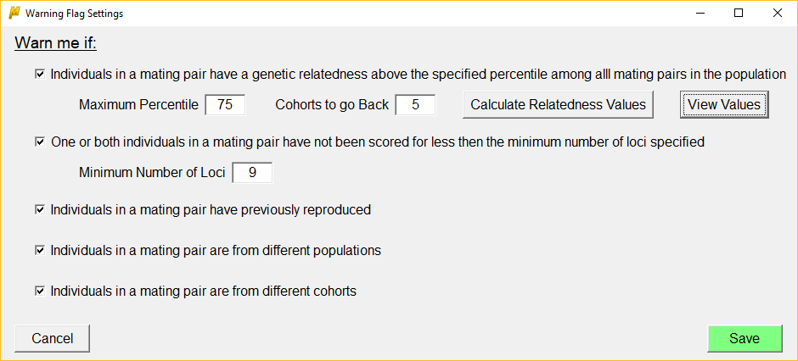

**Mating Design**

Mate Matcher allows for five mating designs:

* 1 to 1 (1 Female mated with 1 Male)
* 1 to 2 (1 Female mated with 2 Males
* 2 to 2 (2 Females each mated with 2 Males)
* 1 to 3 (1 Female mated with 3 Males)
* 3 to 3 (3 Females each mated with 3 Males)

The number of females and males that can be optimized at one time (batch) is dependent upon the mating design, but the upper limit is 10 of each sex. Users are allowed to specify a greater number of males than females to attempt to reduce pairwise relatedness through optimization.

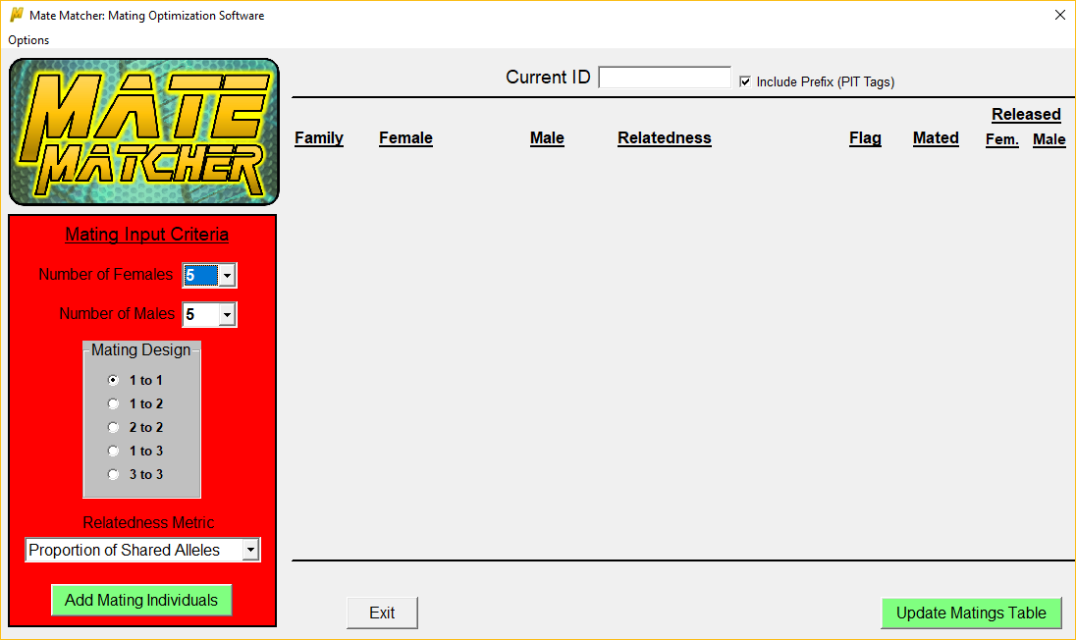

**Relatedness Metric**

The relatedness metric is the value that is optimized when matching mating pairs. For now, the sole option is the Proportion of Shared Alleles which is the count of identical alleles shared between two individuals divided by 2 * number of loci with allelic information present. Therefore, it is assumed that the lower the shared proportion the less likely these two individuals are to share common ancestry.

Additional relatedness measures can be incorporated in the future if demand is present.

**Individual Input Form**

To add individuals for mating optimization, click on the ‘Add Mating Individuals’ button on the main form which opens the individual input window. The number of slots for each sex is dependent upon the mating design and number of females and males specified on the main form.

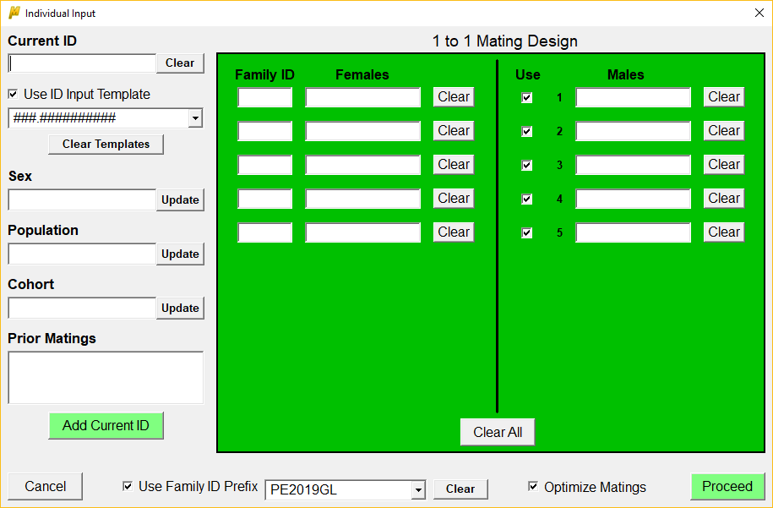

Individual identifiers can be added by either scanning in a PIT tag, copying and pasting, or typing in directly. When typing, it is recommended that you use an ID input template otherwise you will be asked after each keystroke if you want to add the current ID to the genetics table if it isn’t already present. If a template is used, you will only be asked once the entered ID matches the template. To create a template, check the ‘Use ID Input Template’ box, click in the dropdown box beneath it, and type the template. The rules for entering a template are:

* Numbers and letters are represented by the # symbol
  + To add a template for a 5 digit alphanumeric ID you would enter #####
* Symbols are represented by the symbol itself
  + To add a period as the third character in the above template example you would enter ##.##

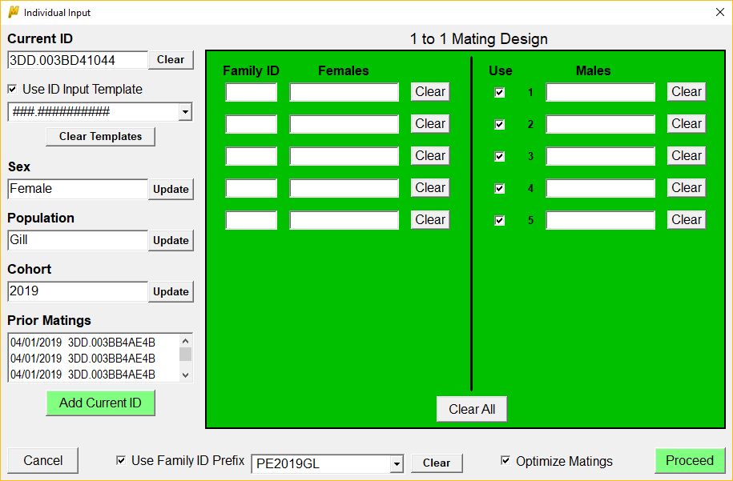

Once your template is matched (if you are using a template), or a character is typed (if you are not using a template), a query is performed on the genetics table to see if that ID is present.

If the ID is present, the sex, population (if checked on the database settings form), and cohort (if checked on the database settings form) information will be queried from the genetics table, and the individual’s involvement in any prior matings will be queried from the matings table.

If the ID is not present, the user will be asked if they would like to add it to the genetics table

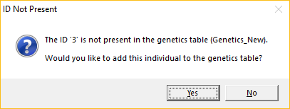

If Yes is selected, the user will be required to supply additional information. Sex information is always required, while population and cohort information is dependent upon whether these optional fields were checked for the genetics table on the database settings form.

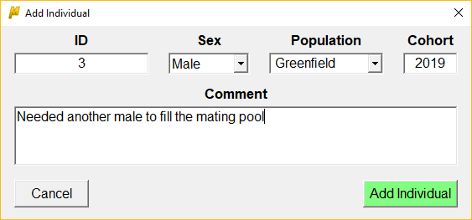

Adding the individual populations the information into the fields on the input form and enables the use of this individual for mating optimization.

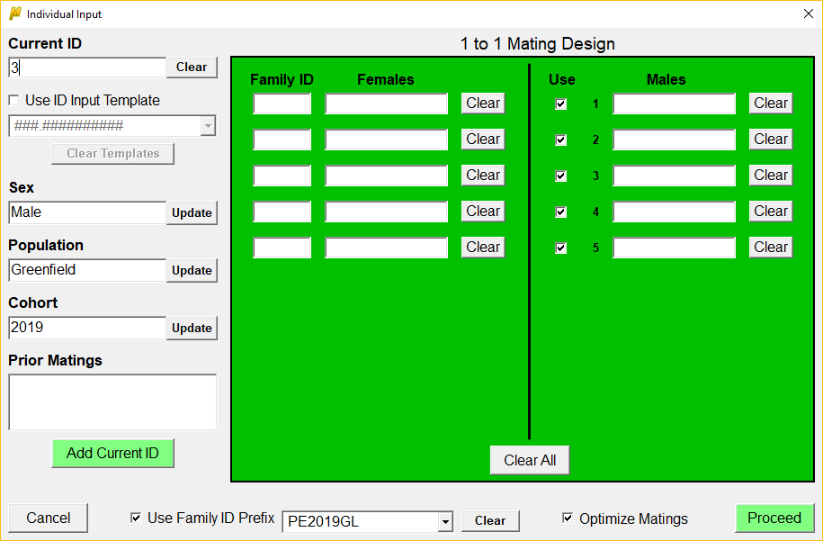

If you choose to not add it to the genetics table you will then be asked if you wish to use the ID without recording it to the genetics table.

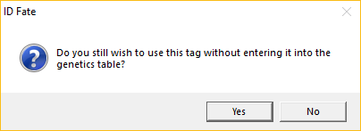

If you choose Yes, then you will be required to enter in information about the individual so that it can be used to evaluate any conditions specified under the ‘Warning Flags Settings’ if it ends up being used in a mating pair.

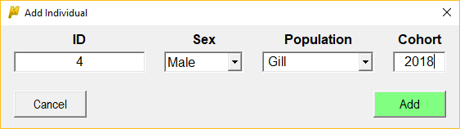

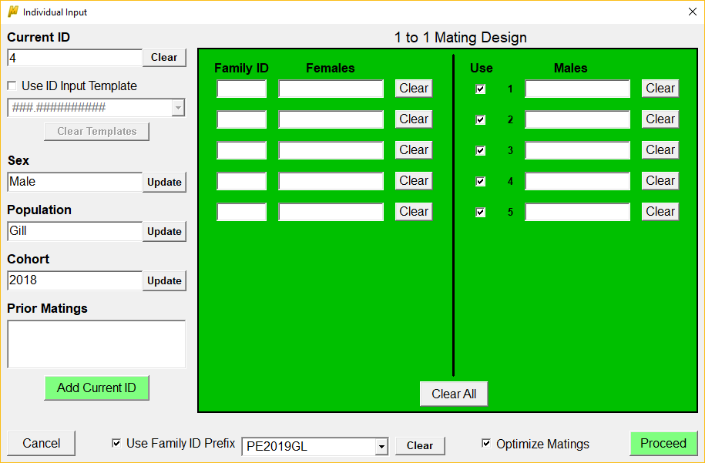

If you choose No, the user will be prompted to enter another ID.

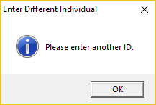

**Updating Individual Information**

Once an individual has either been queried or added to the genetics table or used without recording to the genetics table, its information is populated into the sex, population (if specified), and cohort (if specified) fields. To accommodate issues that may arise from incorrect data, these three fields are able to be updated at this stage, with any changes automatically being updated in the genetics table if the individual was already present or just added.

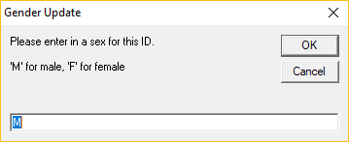

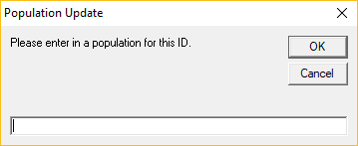

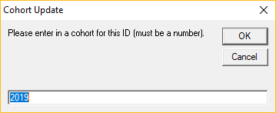

**Creating Mating Pairs**

To add individuals to the mating pool, click on the ‘Add Current ID’ button after you have scanned or entered an ID. The individual will automatically be added to the first available slot under the corresponding sex.

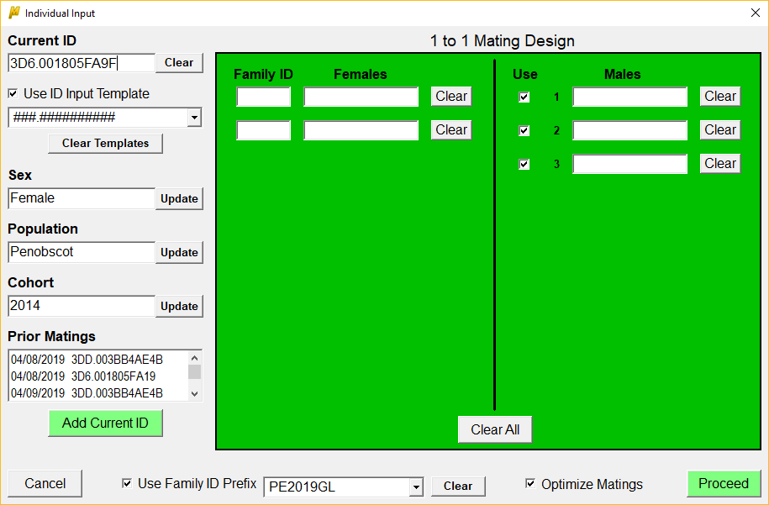

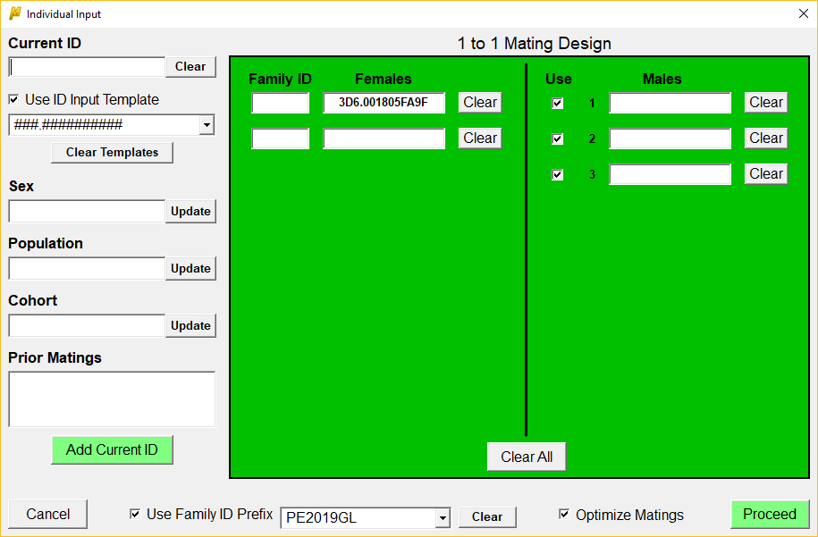

Continue to add individuals until all of the available slots are filled. An added individual can be removed at any time by clicking on the ‘Clear’ button located to the right of the ID number. If this happens you will be asked if you wish to supply a reason for removing the individual.

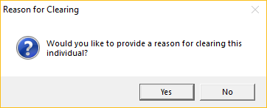

If you choose Yes, the user can either select from a list of reasons queried from the genetics table ‘Comments’ field or type a new one. The reason will then be added to the comments field for the genetics table record of that individual.

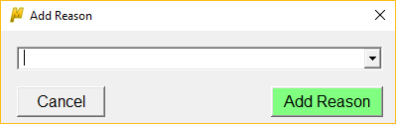

Once all of the mating pool slots have been filled, the user must fill in the Family ID values located to the left of each female before proceeding. The user also has the option of including a prefix that will be added to each family ID. To use a prefix, check the box next to ‘Use Family ID Prefix’ located at the bottom of the page and enter a prefix into the drop-down box. Prefixes will be saved for future use, and can be cleared at any time by clicking the ‘Clear’ button located to the right of the drop-down box.

Lastly, the user has the option to ‘Use’ male candidates. This option is only viable if there is a surplus of male candidates. To exclude a male from being used uncheck the ‘Use’ box to the left of its ID slot.

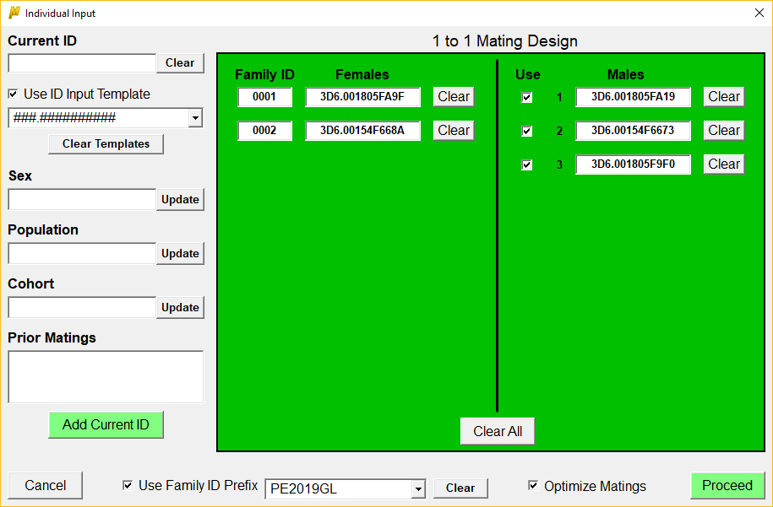

When all settings have been completed, Mate Matcher is ready to create mating pairs. The default is for genetic optimization to be used when creating pairs. However, if the user just wants to use Mate Matcher to record mating pairs and is not interested in optimization or does not have the necessary genetic data to perform optimization, then the ‘Optimize Matings’ check box at the bottom of the form may be unchecked, in which case mating pairs are matched by the order in which they were entered. Finally, click the ‘Proceed’ button to create mating pairs.

**Main Form Part II**

After hitting the ‘Proceed’ button, the matched mating pairs will be listed on the main form.

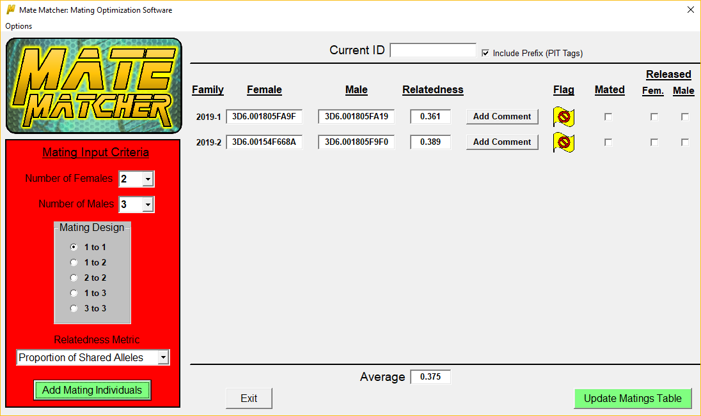

To quickly locate an individual, the user can scan or enter an ID into the ‘Current ID’ text box and the associated tag will by highlighted.

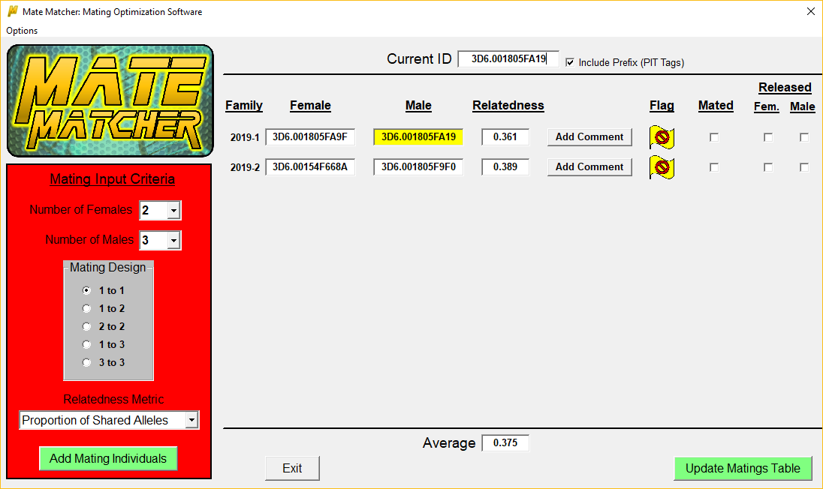

To add any comments about the mating pair, click the ‘Add Comment’ button and enter the text in the pop-up window.

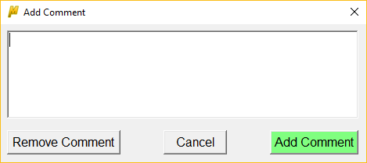

If any of the warning flag settings specified by the user have been violated than a flag will be displayed for the mating pair under the ‘Flag’ column. Clicking on the flag will display a list of the violated flags.

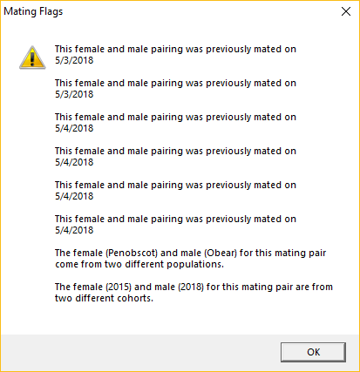

Once a matched pair has been mated, the user should check the associated box under the ‘Mated’ column. When checked, both the female and male will be highlighted in red to indicate that the mating has been completed.

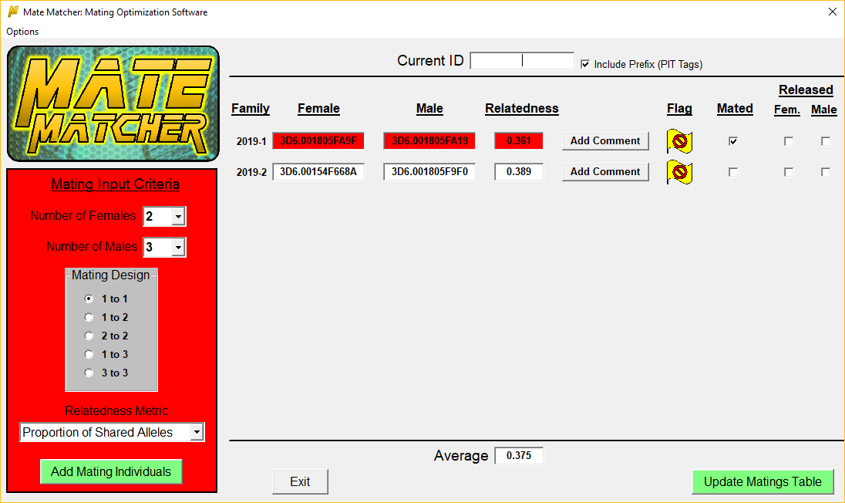

A checked ‘Mated’ box also locks in these individuals and precludes them from being removed if re-optimization becomes necessary.

**Re-optimization**

Re-optimization takes place when at least one of the originally optimized mating pairs has been successfully mated, but one or more individuals from the remaining mating pairs needs to be replaced. To re-optimize, the user clicks the ‘Add Mating Individuals’ button to reopen the Individual Input form. Individuals from pairs that are checked as having been mated will be greyed out, disabling the ability to remove them from the parent pool.

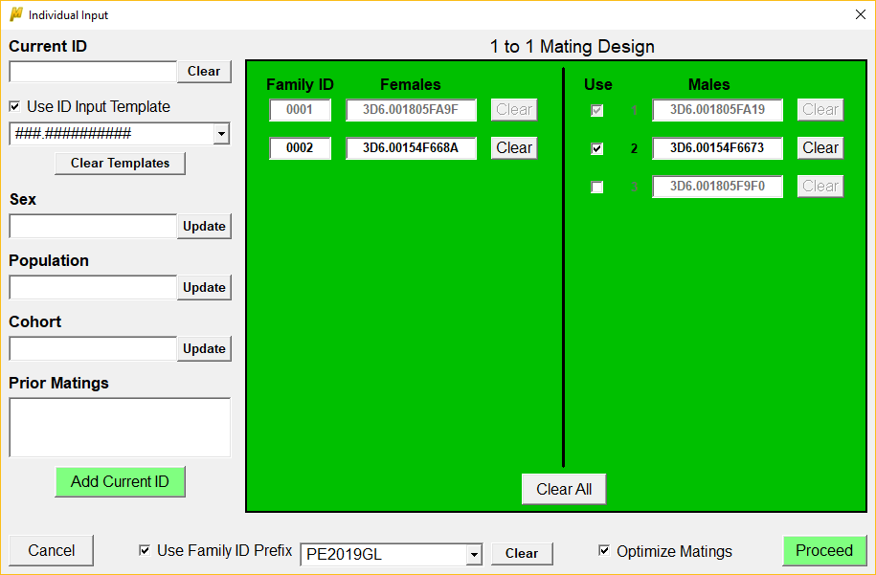

At this point the user can clear and replace any necessary individuals, or if it is a male and there are surplus individuals present in the pool then they have the option of unchecking the ‘Use’ box for that male. Once this is complete the user would then click on the ‘Proceed’ button and mating pair matching occurs again for all of the individuals that aren’t greyed out.

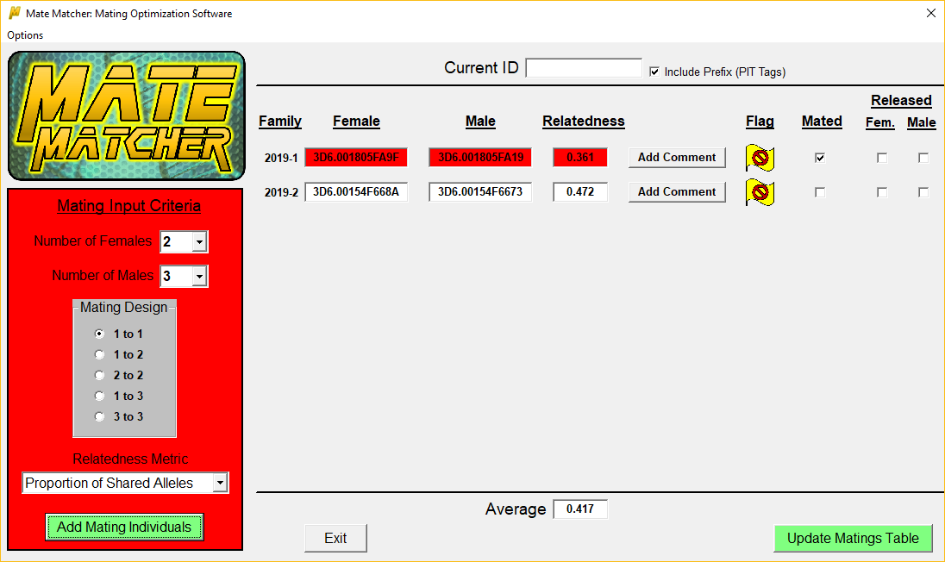

**Appending Mating Pairs**

When all of the matching pairs have been mated, the user can specify if the female, male, or both are going to be released into the wild after mating. Once this is complete, the user needs to record the matings and all of the associated information to the matings table. This is done by clicking on the ‘Update Matings Table’ button. Only mating pairs with the ‘Mated’ box checked will be added to the table.

Mating pairs matched after the initial optimization (like the second pair in the example above) will be labelled as ‘reoptimized’ under the optimized column in the matings table, as opposed to ‘Yes” (first optimization) or ‘No’ (optimize matings is unchecked).

A message will pop-up when the update is complete.

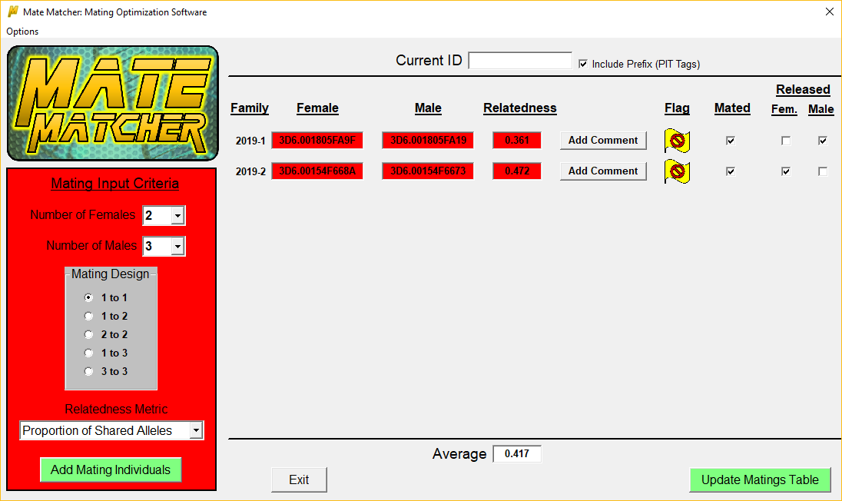

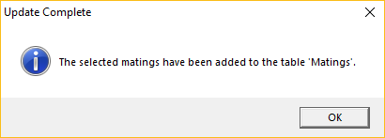

**Recording of Non-optimized Pairs**

An additional table is automatically created for recording the mating pairs that would have occurred if no optimization was employed. This is useful for comparison between optimized and non-optimized matings to quantify decreases in mating pair relatedness compared to random.

The default name for this table is ‘matings_nonopt’. When the user appends mating pairs to the specified matings table, the ‘matings_nonopt’ table is also updated. This is done by reading in the female and male pairs as they were added to the input form. In the below example, 3D6.001805FA9F would be paired with 3D6.001805FA19, and 3D6.00154F668A would be paired with 3D6.00154F6673. In the event that a male’s ‘Use’ box is unchecked or the male has already been mated and is thus disabled, the next available male is used instead.

Information added to the ‘mating_nonopt’ table is the same as that added to the specified matings table with the following exceptions: no comments and no sire/dam release information is recorded.

